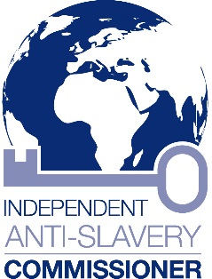
Kevin Hyland OBE
Independent Anti-Slavery Commissioner
+44 (0) 20 3513 0440
iasc@antislaverycommissioner.gsi.gov.uk
5th Floor, Globe House, 89 Eccleston Square, London, SW1V 1PN
Website: www.antislaverycommissioner.co.uk
Twitter: @UKAntiSlavery

House of Commons
SW1A 0AA

Monday 3rd April 2017

Modern Slavery Act – Two Years On

Dear Member of Parliament,

Sunday 26th March marked two years since the Modern Slavery Act 2015 received Royal Assent, and 210 years since the passing of the Slave Trade Act 1807.

As the UK’s first Independent Anti-Slavery Commissioner, responsible for spearheading the country’s response to the barbaric crime of modern slavery, I am committed to seeing more victims supported and more perpetrators punished. I am clear that Members of Parliament can play a key role in making this a reality.

In 2014 the Home Office estimated that there were between 10,000 – 13,000 potential victims of modern slavery in the UK. The fight against slavery requires the resources and efforts of many different actors and organisations; this trade in human misery is taking place in cities, towns and rural communities across the nation on a shameful scale.

In the last two years, there have been many successes and numerous challenges. Many more victims have entered the National Referral Mechanism, the UK’s system of support for victims of modern slavery. Numbers have risen from 2340 in 2014 to 3805 in 2016. In addition, more criminals are being prosecuted and convicted. To access statistics on this, please visit the resources page of my website: http://www.antislaverycommissioner.co.uk/resources/

The Prime Minister has made this a priority and now chairs a Taskforce on modern slavery, hosting regular meetings at Downing Street with relevant departments to coordinate the UK fight. In addition the Home Secretary recently announced £8.5 million funding to police to boost their response to the crime and a further £33.5 million has been committed by the Government to address the root causes of modern slavery overseas.

Since the Act received Royal Assent, statutory agencies have stepped up anti-slavery efforts. With pressure from my office, combating the crime has been made a high priority threat for the UK’s National Crime Agency; UK police have begun conducting more investigations across the country; and the Work and Pensions Select Committee is carrying out an inquiry into access to welfare benefits for all victims of modern slavery.

Additionally, I have made recommendations to Government on responding to modern slavery in humanitarian crises, including the refugee and migrant crisis; I have worked with NHS England and South East England Councils on raising awareness of staff so that they can identify potential cases of slavery; I have led efforts to secure a clear target on modern slavery in the UN’s Sustainable Development Goals, raising the profile of the crime internationally; and I have ensured increased levels of priority and funding are devoted to tackling modern slavery globally.

Furthermore, with the UK the first country in the world to bring in legislation on transparency in supply chains of companies, businesses have begun to openly engage on the issue. Cases of modern slavery have been identified, shared and no longer kept hidden. Specific companies have started to lead the way in responding to modern slavery by going above and beyond the requirements of the Act.

As Members of Parliament you are in a position to help drive forward change, whether through raising awareness among your constituents and the public, making sure local businesses are transparent with their supply chains, holding law enforcement agencies to account or working with local authorities on safeguarding standards, ensuring they are better equipped to identify victims, support the vulnerable and disrupt criminal networks. Two years on since the passing of the Modern Slavery Act, we can no longer make an excuse that this is something new to implement. Members of Parliament worked hard to pass the bill, which gained cross-party support, and now we need to make sure that the tools it has provided are being used to their full potential.

I am already working closely with the All Party Parliamentary Group on Modern Slavery and Human Trafficking, and as the Independent Anti-Slavery Commissioner, I will continue to monitor how modern slavery is being responded to across the UK. I want to engage further with Members of Parliament during this process, so please do not hesitate to contact me should you need help in addressing modern slavery in your constituency. For more details on my current priorities and progress, please see my Annual Report which can be found on my website here: http://www.antislaverycommissioner.co.uk/media/1097/annual-report-2016.pdf

I look forward to working with you as together we protect vulnerable people and rid the United Kingdom, and the world, of the scourge of modern slavery – a crime that the UK Prime Minister has called ‘the great human rights issue of our time’.

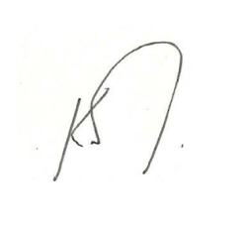
Kind regards,

Kevin Hyland
Independent Anti-Slavery Commissioner

